09-09-2026

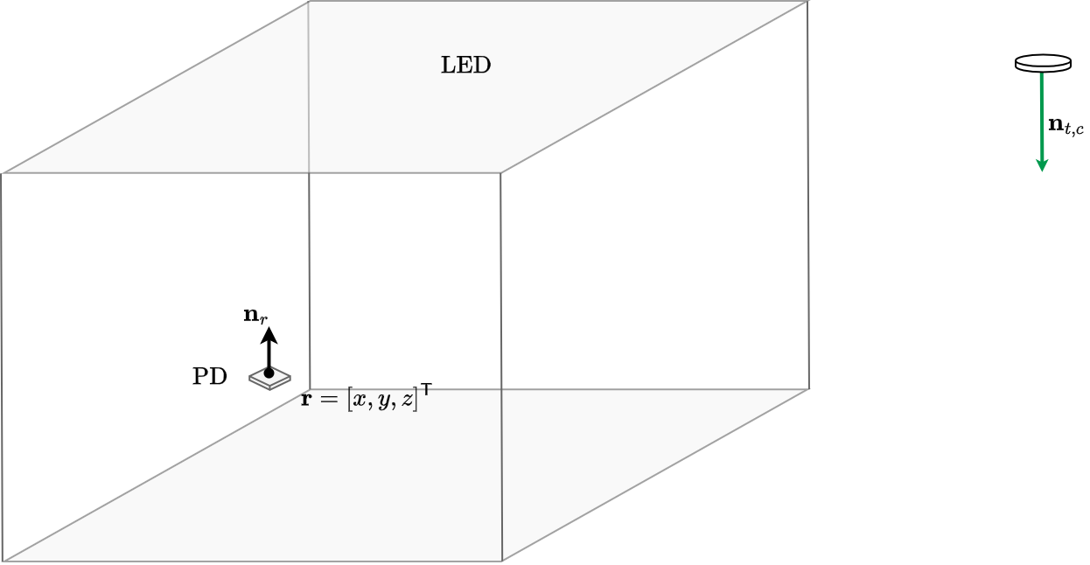


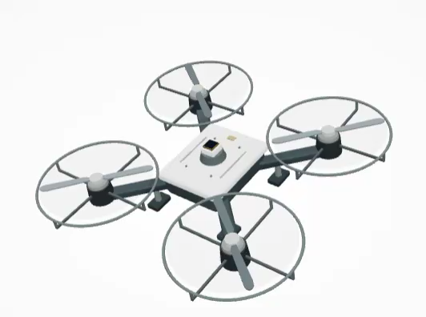

Related work

Compilation of the receiver systems that generate information divergence

The idea is to identify in the state of the art the types of user-side RX that have been proposed in the STATE OF THE ART in order to compile the current proposals, compare them and include them in the “virtual testbed”.

For now I have identified two categories of receiver systems that can generate diversity: rotating and static.

Category 1: Rotating Systems at the Receiver

Z. Wang, 2024, “Design and Performance Analysis for Indoor Visible Light Positioning With Single LED and Single-Tilted-Rotatable PD”

Summary: 2D position estimation, rotating system, considering first-order reflections, CRLB study to choose the tilt angle and the number of samples per rotation. Regarding the 2D estimation method: LS, GWO, IGWO. Carried out in SIMULATION (CDF_90%= 11cm, testbed: 5 x 5 x 3 m) and EXPERIMENTALLY (APE = 0.9cm , 50 cm x 50 cm x 30 cm)

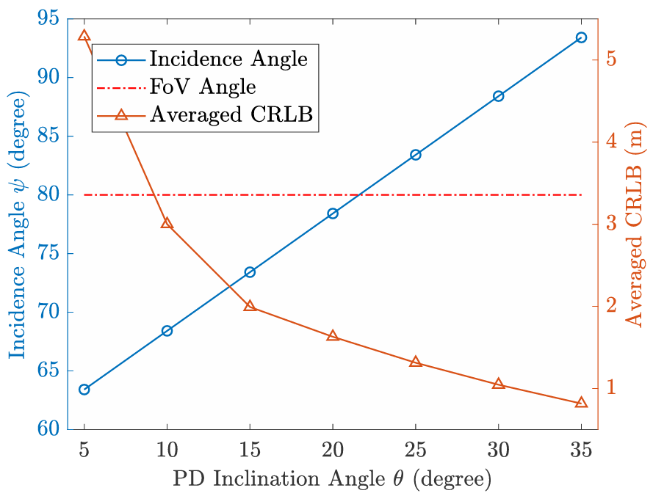
Figure: Incidence angle at the farthest 2D position. Trade-off between increasing the angle (more information) to reduce the error vs. incidence angle within the FOV (related to coverage)

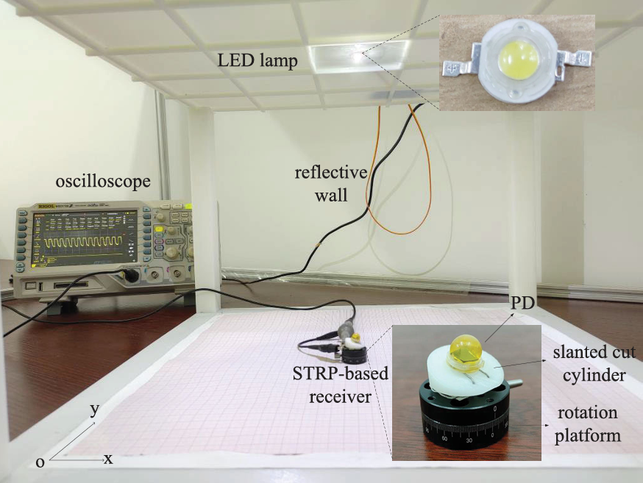

R. Liu, 2022, “Machine Learning Based Visible Light Indoor Positioning With Single-LED and Single Rotatable Photo Detector”

Summary: 2D estimation, rotating system, first-order reflections. Does not derive the CRLB. Estimation method: (1) Rotatable Positioning Model RSS + geometry (2) Machine learning (trained with simulated data: 5929 sets) Random-Forest (region classification: Interior, Wall, corner) + ELM (neural network). Results: Simulation (4m x 4m x 3.1m) with method (1) 12cm and with method (2) APE: 1.74cm. With length=10cm.

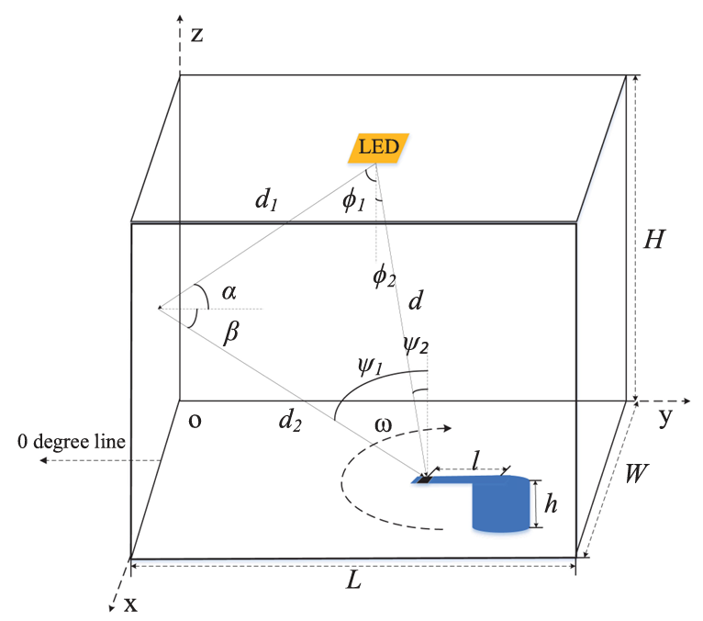

H. Shi, 2025, “Visible Light Positioning Using a Single LED and a Single Rotatable Photodetector”

Summary: 2D estimation. They complete the study of (Liu,2022): they derive the missing CRLB and study the rod length and the rotation angles. Positioning method: LS. Results: Design: N=4, length=20cm. Simulation: (testbed: 5x5x4) APE=2.52cm. Experimental: APE=4.96cm (Testbed=50cm x 50cm).

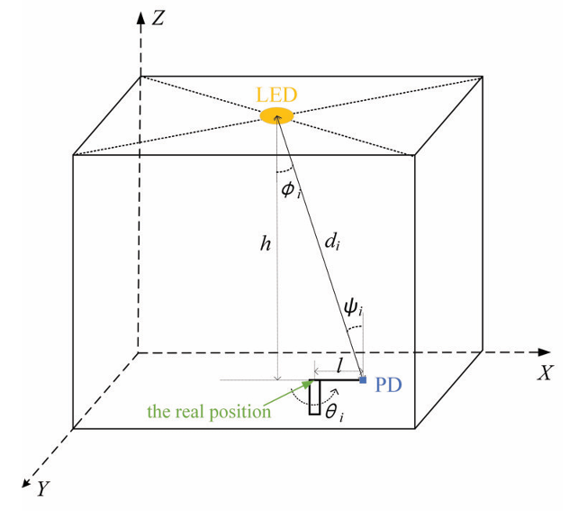
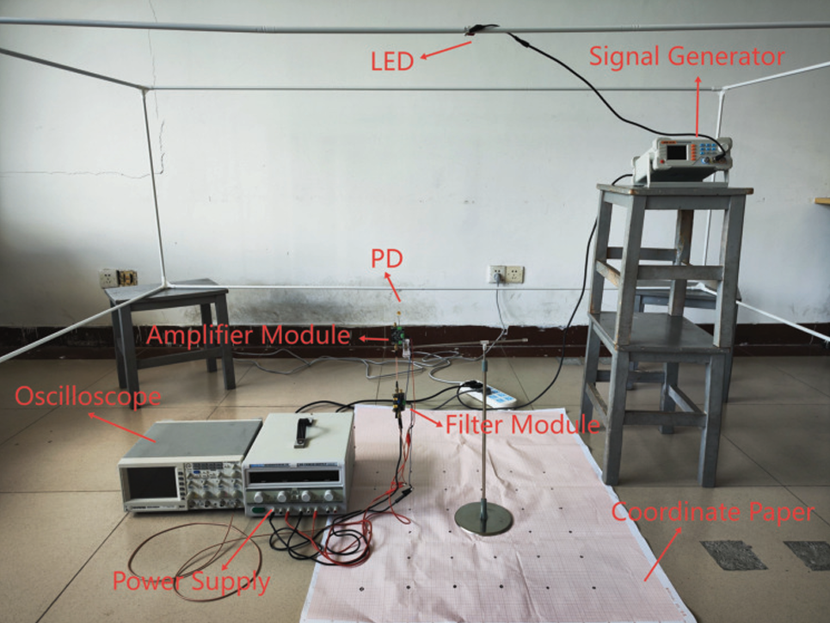
H. Shi, 2026, “Performance Comparison and Improvement for VLP With a Single LED and a Single Rotatable PD”

Summary: 2D estimation. The paper compares two single-LED/single-PD rotating receiver architectures: the Single-Tilted-Rotatable PD (STRP) and the Single-Horizontal-Rotatable PD (SHRP). The CRLB is derived considering both thermal noise and signal-dependent shot noise (SDSN), showing that the STRP provides better positioning performance. Based on the STRP, an Adaptive-Tilt-Angle-Adjustment (ATAA) method is proposed – 2DoF.

ATAA starts with a fixed tilt angle of 20° and performs 4 rotations separated by 90° to obtain an initial LS position estimate. Based on this estimated position and the PD FOV constraint, the method determines the maximum feasible tilt angle. The tilt is then adaptively increased or decreased in 1° steps until all four rotations can still receive the optical signal. Finally, another set of 4 measurements is acquired and the position is estimated again using LS.

Results: SIMULATION only. Test area: X,Y = 0.2–4.8 m with 0.2 m spacing, 576 test points, h = 3 m, P_LED = 5 W. LS: APE = 5.03 cm, maximum error = 11.54 cm. ATAA: APE = 2.50 cm, maximum error = 6.80 cm. Hardware implementation of the adaptive STRP receiver is left as future work.

Main idea: Trade-off between increasing the tilt angle to generate larger RSS differences among the four orientations and maintaining all measurements within the PD FOV. The optimal tilt therefore depends on the estimated receiver position.

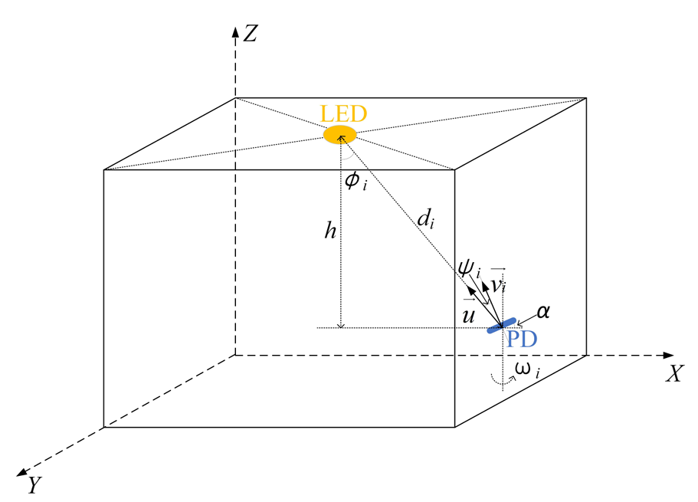

Category 2: Static Systems at the Receiver

S. Ma, 2024, “Centimeter-Level 3-D Mobile Online Visible Light Positioning System With Single LED Lamp”

Summary: 3D estimation. Estimation method: Nonlinear least squares (NLS), sequential quadratic programming (SQP) (b) deep learning. Results: DL: 1.77cm.

Parameters: A_PD 1cm x1cm.

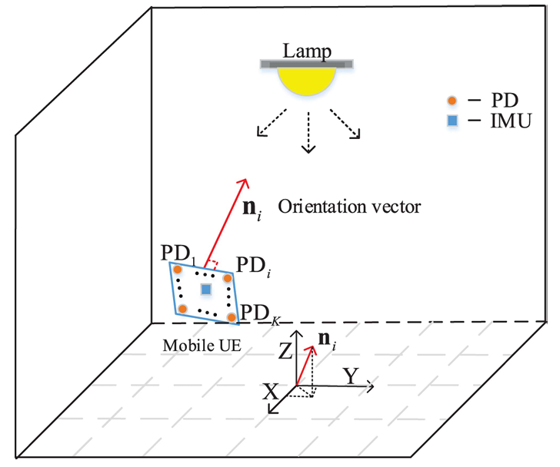
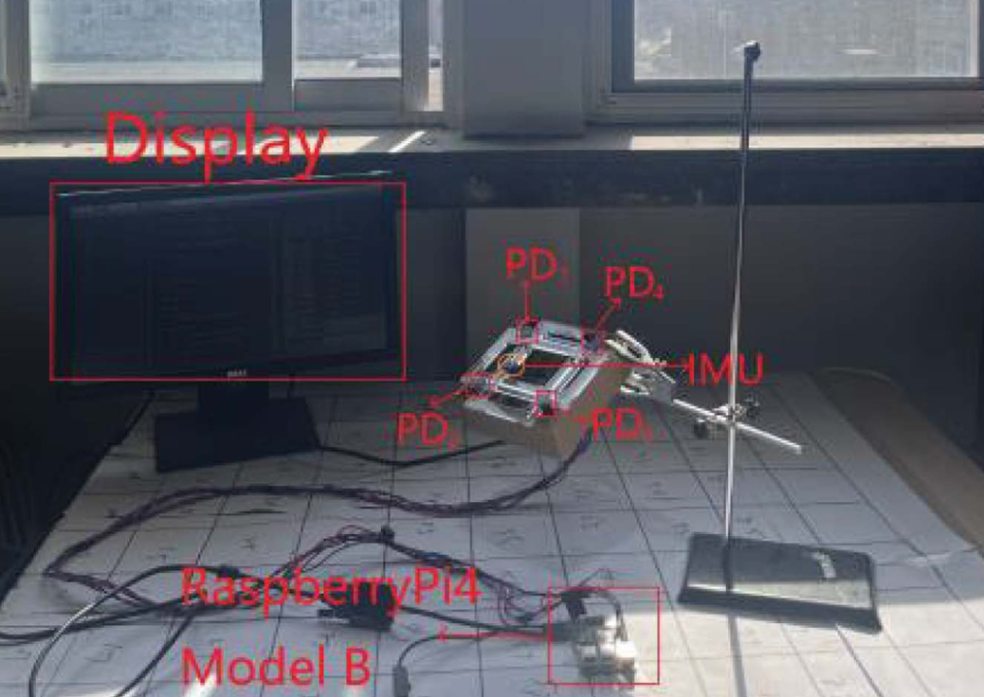

L. Qin, 2021, “High precision indoor positioning algorithm of single LED lamp based on A-Bayes”

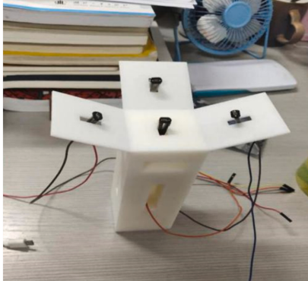

Summary of systems

Rotatable:

Z. Wang, 2024: Single Tilted-Rotatable PD (STRP)

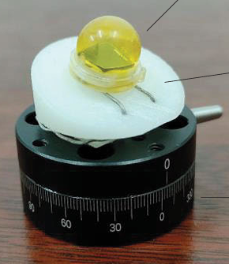

R. Liu, 2022; H. Shi, 2025: Single Rotatable PD (SRP)

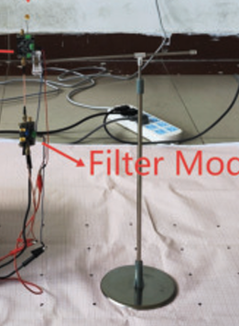

Static:

S. Ma, 2024: Array of 4 PDs

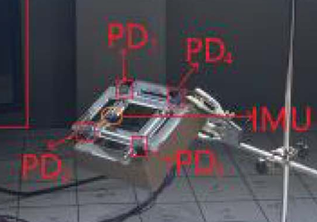


L. Qin, 2021, “High precision indoor positioning algorithm of single LED lamp based on A-Bayes”

